58th Ohio Guard Regiment

# | Fate | Last Name | First Name | Rank | Reg | State | Co. | Age | Comments
 | Lived | Friesner   | William Shields  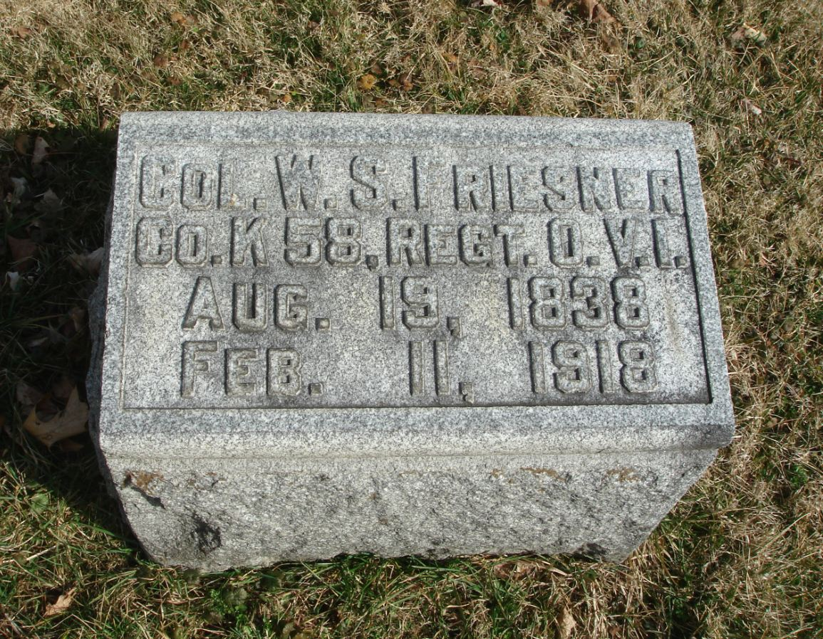 | Capt. | 58 | OH Inf. | A | 26 | - Lived – McCown file,  - Daily Missouri Democrat, Fort Pickering List – (as Fooser)  - Cincinnati Daily Enquirer, Fort Pickering List – (as Fooser)  - Cincinnati Daily Commercial, Fort Pickering List – (as Fooser)  - Still Living in 1892 List  - Ohio Adjutant General’s Report – Transferred from Co. K to Co. A, Battalion, Dec. 26, 1864; promoted to Lieut. Colonel May 3, 1865. (Vol. 5, p. 169)  - Fold3.com – Pension Application – Died Feb. 11, 1918, at Logan, OH.  - Findagrave.com – Born Aug. 19, 1838, Died Feb. 11, 1918. Buried at Forest Rose Cemetery, Lancaster, OH.  - Rootsweb OH List – Born Logan, OH, 1838.  - Personal File of William Elder – Mentioned as surviving Sultana.  - Personal File – Statement given to Washburn Commission.  - Personal File – Testimony at Speed Trial.  - Personal File – Reminiscence in The Logan [OH] Daily News, Sesquicentennial Edition, June 27, 1966.
 | Lived | Sollenbarger   | Seth Wilhelm  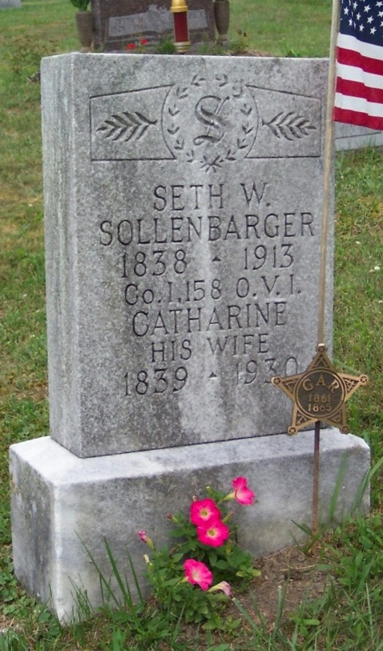 | Sgt. | 58 | OH Inf. | A | 27 | - Memphis Argus – Gayoso Hospital List – (as Sullenberger)  - Memphis Daily Bulletin – Gayoso Hospital List – (as Sullenberger)  - Daily Missouri Democrat, Gayoso Hospital List – exhaustion. (as Sullenberger)  - Daily Missouri Republican, Gayoso Hospital List – Exhaustion. (as Sullenberger)  - Cincinnati Daily Commercial, Gayoso Hospital List – (as Sullenberger)  - Cincinnati Daily Gazette, Gayoso Hospital List – (as Sullenberg)  - Still Living in 1892 List  - Ohio Adjutant General’s Report – Transferred from Co. K as Corporal Dec. 26, 1864; appointed Sergeant Feb 1, 1865; mustered out with company Sept. 16, 1865; veteran. (Vol. 5, p. 169)  - Fold3.com – Pension Application – Died Feb. 20, 1913.  - Findagrave.com – Born April 12, 1838, Died Feb. 20, 1913. Buried at Saint Matthews Lutheran Cemetery, Sugar Grove, OH.  - Findagrave.com – “In the accident he received a hip injury and my mother… said that he had the calf of his leg blown off at some point of the war, perhaps that is the injury that also happened in the explosion of the Sultana.”  - Chicago Archives – “Str. ‘Sultana’ Survivors” List. (as Suttenberger)  - Record of Officers & Men on Board the Steamer Sultana - Survived and Perished (page 207) – Survived (as Sultenberger)  - Fold3.com – List of Federal prisoners who survived the Sultana – Exhausted.  - Cincinnati Weekly Commercial, May 4, 1865 - Known to be on the Sultana – (as Sollenberger)  - Personal File of William Elder – Jumped off Sultana at same time as Elder. Mentions how Sollenbarger survived.  - Personal File – Obituary – Lewisburg [OH] Leader, March 6, 1913. Mentions Sultana.  - Personal File – Information from gr granddaughter Darleen Barens. Injured hip and possibly calf.
 | Lived | Elder | William H.  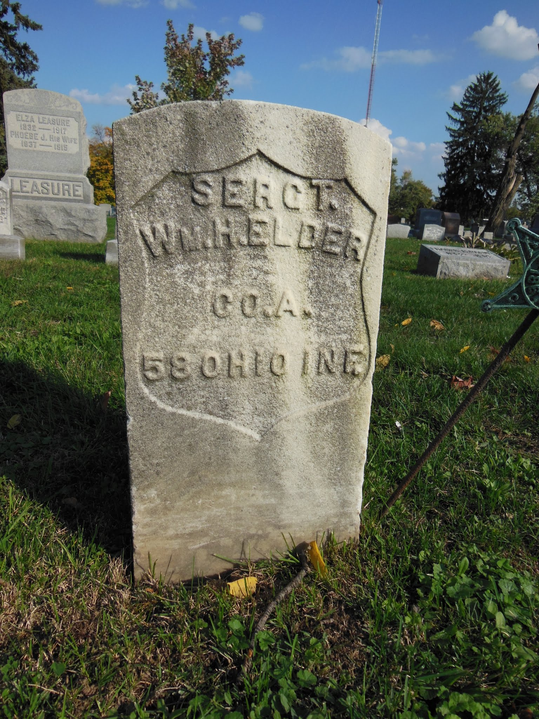 | Cpl. | 58 | OH Inf. | A | 20 | - Daily Missouri Republican, Soldier’s Home List.  - Cincinnati Daily Commercial, Soldier’s Home List.  - Cincinnati Daily Gazette, Soldier’s Home List.  - Pocohontas List  - Still Living in 1892 List  - Ohio Adjutant General’s Report – Transferred from Co. H Dec. 26, 1864; appointed Corporal March 1, 1865; Sergeant June 1, 1865; mustered out with company Sept. 16, 1865; veteran. (Vol. 5, p. 169)  - Fold3.com – Pension Application – Died Feb. 23, 1913.  - Findagrave.com – Born July 14, 1844, Died Feb. 23, 1913. Buried at Union Cemetery, Columbus, OH.  - Chicago Archives – “Str. ‘Sultana’ Survivors” List.  - Record of Officers & Men on Board the Steamer Sultana - Survived and Perished (page 174) – Survived  - Obituary – The Coshocton [OH] Tribune, Tuesday, Feb. 25, 1913.  - Obituary - The Democratic Banner (Mt. Vernon, OH) February 25, 1913, Page 1.  - Fold3.com – List of Federal prisoners who survived the Sultana.  - Cincinnati Weekly Commercial, May 4, 1865 - Known to be on the Sultana.  - Newspaper Account – Athens [OH] Daily Messenger, May 3, 1912. Received broken right arm.
 | DIED | Branum | Robert | Pvt. | 58 | OH Inf. | A |  | - Ohio Adjutant General’s Report – Transferred from Co. H as Brannon, Robert; Dec. 26, 1864; perished by explosion of steamer Sultana on Mississippi River, near Memphis, Tenn., April 27, 1865; veteran. (Vol. 5, p. 170)
 | DIED | Elick  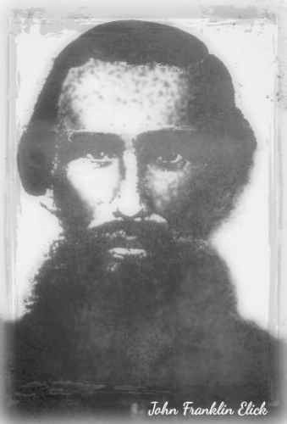 | John | Pvt. | 58 | OH Inf. | A | 32 | - Ohio Adjutant General’s Report – Transferred from Co. H Dec. 26, 1864; perished by explosion of steamer Sultana on Mississippi River, near Memphis, Tenn., April 27, 1865; veteran. (Vol. 5, p. 171)  - Fold3.com – Pension Application – Widow’s Pension, June 12, 1865.  - Fold3.com – Widow’s Pension – Minor’s application, “Drowned by explosion of Steamer Sultana on the Miss. R. April 27/65.”  - Ancestry.com – Born 1833, died April 27, 1865. (Three sons, one daughter – last son born Feb. 4, 1865)
 | Lived | Hines  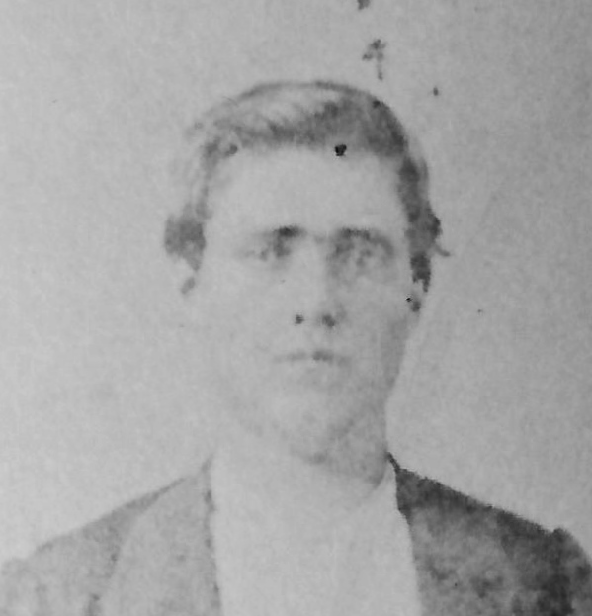 | James Knox Polk  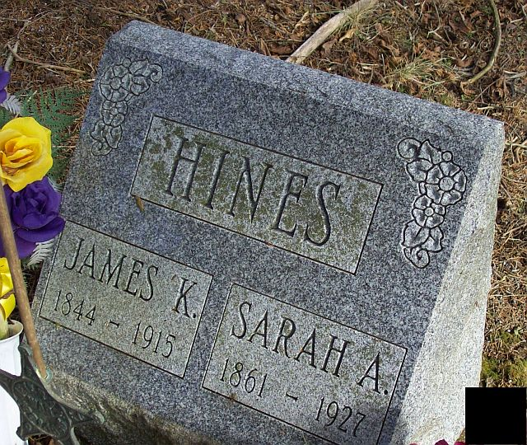 | Pvt. | 58 | OH Inf. | A | 20 | - Memphis Daily Bulletin – Adams Hospital – (on Gayoso List)  - Daily Missouri Democrat, Adams Hospital -slight scalds (as 68 OH Inf.)  - Daily Missouri Republican, Adams Hospital List – Scalded slightly. (as 68 OH Inf.)  - Cincinnati Daily Commercial, Adams Hospital - (on Gayoso List).  - Cincinnati Daily Gazette, Adams Hospital – (on Gayoso List)  - Ohio Adjutant General’s Report – Transferred from Co. H Dec. 26, 1864; mustered out with company Sept. 16, 1865; veteran. (Vol. 5, p. 171)  - Fold3.com – Pension Application – Died April 1, 1915, at Lancaster, OH.  - Findagrave.com – Born Oct. 27, 1844, Died April 1, 1915. Buried at Pine Grove Church Cemetery, Revenge, OH.  - Chicago Archives – “Str. ‘Sultana’ Survivors” List.  - Record of Officers & Men on Board the Steamer Sultana - Survived and Perished (page 181) – Survived (as Hine)  - Obituary Notice – Lancaster [OH] Daily Eagle, April 2, 1915, p. 9. Mentions Sultana.  - Fold3.com – List of Federal prisoners who survived the Sultana – (as Hine) Slightly scalded.  - Cincinnati Weekly Commercial, May 4, 1865 - Known to be on the Sultana.  - Personal File of William Elder – Mentioned as surviving Sultana.  - Personal File – Obituary clipping. Mentions Sultana.
 | DIED | Keistler | Jacob | Pvt. | 58 | OH Inf. | A |  | - Ohio Adjutant General’s Report – Transferred from Co. K Dec. 26, 1864; perished by explosion of steamer Sultana on Mississippi River, near Memphis, Tenn., April 27, 1865; veteran. (Vol. 5, p. 172)
 | DIED | Kinser | Christopher | Pvt. | 58 | OH Inf. | A |  | - Ohio Adjutant General’s Report – Transferred from Co. H as a Wagoner Dec. 26, 1864; perished by explosion of steamer Sultana on Mississippi River, near Memphis, Tenn., April 27, 1865; veteran. (Vol. 5, p. 171)  - Fold3.com – Pension Application – Widow’s Pension, Sept. 9, 1865.  - Fold3.com – Widow’s Pension – “Drowned by Explosion of Steamer Sultana on Miss. River April 27/65.”
 | Lived | Sanderson | John  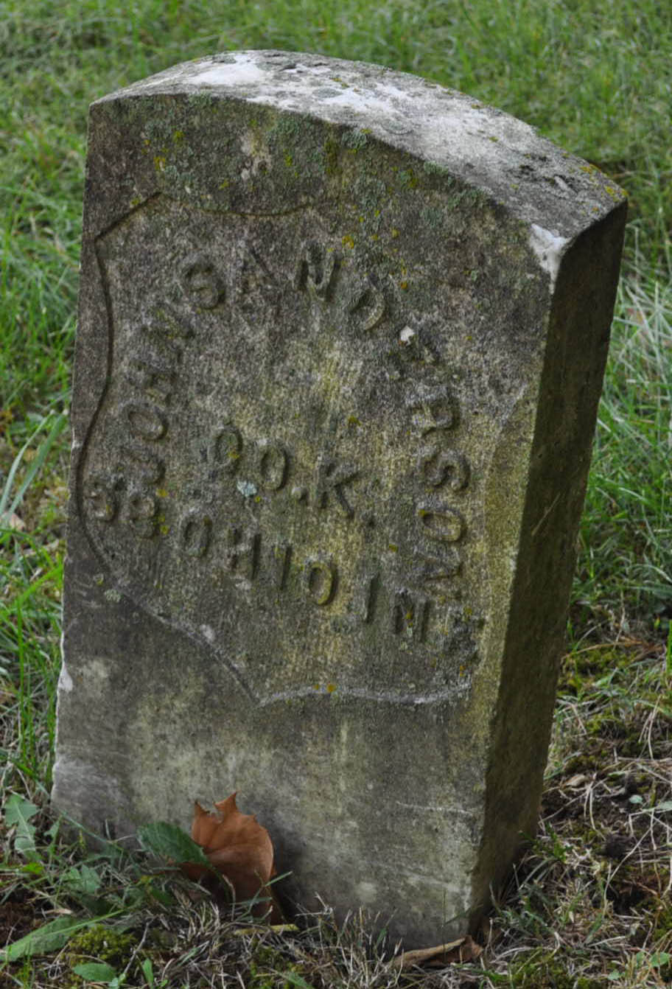 | Pvt. | 58 | OH Inf. | A | 20 | - Ohio Adjutant General’s Report – Transferred from Co. K Dec. 26, 1864; mustered out with company Sept. 16, 1865; veteran. (Vol. 5, p. 174)  - Fold3.com – Pension Application – Died Dec. 14, 1914, at Topeka, KS.  - Findagrave.com – Born Dec. 1844, Died Dec. 14, 1914. Buried at Mount Auburn Cemetery, Topeka, KS.  - Personal File of William Elder – Mentioned as surviving Sultana.
 | DIED | Stuller | James | Pvt. | 58 | OH Inf. | A |  | - Ohio Adjutant General’s Report – Transferred from Co. K Dec. 26, 1864; perished by explosion of steamer Sultana on Mississippi River, near Memphis, Tenn., April 27, 1865; veteran. (Vol. 5, p. 174)  - Fold3.com – Pension Application – Mother’s Pension, Sept. 28, 1871.  - Mentioned by Friesner in “William S. Friesner of Logan Commanded Detail on Ill-Fated Sultana,” The Logan [OH] Daily News, Sesquicentennial Edition, June 27, 1966, p. 26.
 | DIED | Wells | William | Pvt. | 58 | OH Inf. | A |  | - Ohio Adjutant General’s Report – Transferred from Co. I Dec. 26, 1864; perished by explosion of steamer Sultana on Mississippi River, near Memphis, Tenn., April 27, 1865; veteran. (Vol. 5, p. 175)
 | DIED | Wilson | Samuel | Pvt. | 58 | OH Inf. | A | 40 | - Ohio Adjutant General’s Report – Transferred from Co. H Dec. 26, 1864; perished by explosion of steamer Sultana on Mississippi River, near Memphis, Tenn., April 27, 1865; veteran. (Vol. 5, p. 174)  - Fold3.com – Pension Application – Mother’s pension, Dec. 31, 1866.  - Ancestry.com – Born about 1825, Died April 27, 1865.
 | DIED | Hawken | John | Cpl. | 58 | OH Inf. | B |  | - Ohio Adjutant General’s Report – Transferred from Co. F Dec. 26, 1864; perished by explosion of steamer Sultana on Mississippi River, near Memphis, Tenn., April 27, 1865; veteran. (Vol. 5, p. 177)  - Fold3.com – Pension Application – Widow’s pension, July 1, 1865.  - Fold3.com – Widow’s Pension – “was a Corporal and that he was drowned while guarding paroled Prisoners on Steamer Sultana April 27, 1865.”
 | DIED | Campbell | Hiram | Pvt. | 58 | OH Inf. | B |  | - Ohio Adjutant General’s Report – Transferred from Co. C Dec. 26, 1864; perished by explosion of steamer Sultana on Mississippi River, near Memphis, Tenn., April 27, 1865; veteran. (Vol. 5, p. 178)  - Fold3.com – Pension Application – Widow’s pension, Aug. 12, 1865.  - Fold3.com – Widow’s Pension – “was Drowned while guarding Paroled prisoners on Steamer Sultana April 27, 1865.”  - Newspaper article – Daily Ohio Statesman [Columbus, OH], July 17, 1868 – “effects of deceased soldiers… found in the office of the Superintendent of the State House.” “Hiram Campbell… killed by explosion of the Sultana.”
 | DIED | Kenz | George | Pvt. | 58 | OH Inf. | B |  | - Ohio Adjutant General’s Report – Transferred from Co. __ Dec. 26, 1864; perished by explosion of steamer Sultana on Mississippi River, near Memphis, Tenn., April 27, 1865; veteran. (Vol. 5, p. 179)  - Fold3.com – Pension Application – Widow’s pension, Dec. 21, 1865.  - US Resisters of Deaths of Volunteers, Ohio, Vol. 4, p. 37.
 | DIED | Mowry | John | Pvt. | 58 | OH Inf. | B | 44 | - Ohio Adjutant General’s Report – Transferred from Co. F Dec. 26, 1864; perished by explosion of steamer Sultana on Mississippi River, near Memphis, Tenn., April 27, 1865; veteran. (Vol. 5, p. 179)  - Fold3.com – Pension Application – Widow’s pension, June 8, 1865.  - Fold3.com – Widow’s Pension – Minor’s pension, “Adj. Gen. reports death on Steamer Sultana, April 27, 1865.”  - Ancestry.com – Born Sept. 11, 1820, Died April 27, 1865.  - Personal File - Mowery Family Papers. Body washed ashore and buried.
 | DIED | Neustadt | David | Pvt. | 58 | OH Inf. | B |  | - Ohio Adjutant General’s Report – Transferred from Co. A Dec. 26, 1864; perished by explosion of steamer Sultana on Mississippi River, near Memphis, Tenn., April 27, 1865. (Vol. 5, p. 179)
 | Lived | Wolfkammer | John  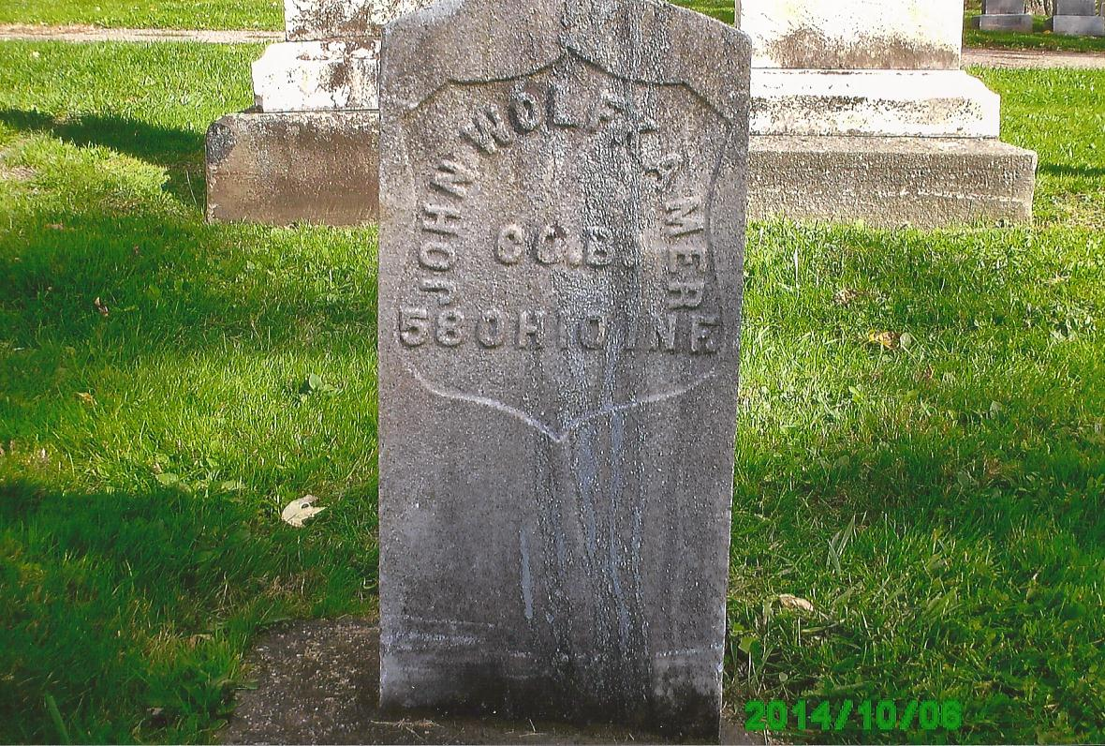 | Pvt. | 58 | OH Inf. | B | 40 | - Daily Missouri Republican, Soldier’s Home List – (as Wolfkemmer)  - Cincinnati Daily Commercial, Soldier’s Home List (as Wolfkemmer)  - Cincinnati Daily Gazette, Soldier’s Home List – (as Wolfkemmer)  - Pocohontas List (as Wolekamer)  - Ohio Adjutant General’s Report – Transferred from Co. C as John Wulfkammer Dec. 26, 1864; mustered out June 2, 1865, at Columbus, O., by order War Department. (Vol. 5, p. 181)  - A Portrait and Biographical Record of Portage and Summit Counties, Ohio, (p. 806) – Lived  - Fold3.com – Pension Application – Died Jan. 30, 1889. (as Wolfkammer)  - Findagrave.com – Born Aug. 24, 1824 (Germany), Died Jan. 30, 1889. Buried at Locust Grove Cemetery, Twinsburg, OH.  - Chicago Archives – “Str. ‘Sultana’ Survivors” List.  - Record of Officers & Men on Board the Steamer Sultana - Survived and Perished (page 216) – Survived (as Walfkecher)  - Fold3.com – List of Federal prisoners who survived the Sultana.  - Cincinnati Weekly Commercial, May 4, 1865 - Known to be on the Sultana – (as Wolfkamer)  - Personal File – Biographical sketch in Portrait and Biographical Record of Portage and Summit Counties, Ohio. Mentions how he was saved from Sultana.
 | DIED | Baada | Phillip | Pvt. | 58 | OH Inf. | C |  | - Ohio Adjutant General’s Report – Transferred from Co. E Dec. 26, 1864; perished by explosion of steamer Sultana on Mississippi River, near Memphis, Tenn., April 27, 1865. (Vol. 5, p. 183)
 | DIED | Bauer | John C. | Pvt. | 58 | OH Inf. | C |  | - Ohio Adjutant General’s Report – Transferred from Co. D as John C. Bauer Dec. 26, 1864; perished by explosion of steamer Sultana on Mississippi River, near Memphis, Tenn., April 27, 1865. (Vol. 5, p. 183)  - Fold3.com – Widow’s Pension – “Died by reason of explosion of Steamer Sultana April 27, 1865.”
 | DIED | Young | Frederick | Pvt. | 58 | OH Inf. | C |  | - Ohio Adjutant General’s Report – Transferred from Co. E as Frederick Zung Dec. 26, 1864; perished by explosion of steamer Sultana on Mississippi River, near Memphis, Tenn., April 27, 1865. (Vol. 5, p. 186)
 | DIED | Bresen | Peter | Pvt. | 58 | OH Inf. | D |  | - Ohio Adjutant General’s Report – Perished by explosion of steamer Sultana on Mississippi River, near Memphis, Tenn., April 27, 1865. (Vol. 5, p. 188)

James K. Hines was a private of Company A, 58th Ohio Infantry. In April 1865, the 58th Ohio was stationed near Vicksburg, MS. On April 24, one captain, one sergeant, two corporals, and 18 privates, 22 total, were assigned to act as a guard unit for the transport of over 2,000 recently released Union prisoners-of-war on the Mississippi steamboat Sultana. 2:00 a.m. on April 24, 1865, when the Sultana was seven miles north of Memphis, TN, her boilers exploded. Over 1,500 people lost their lives. Private Hines was pulled from the river and taken to Adams Hospital in Memphis suffering from "slight scalds."

Lived – 6
Died - 16

